DATE: 07-07-26
Retrieving Data Using the SQL SELECT Statement

1.Determine the Structure of DEPT Table and its Contents.
Structure of DEPT:
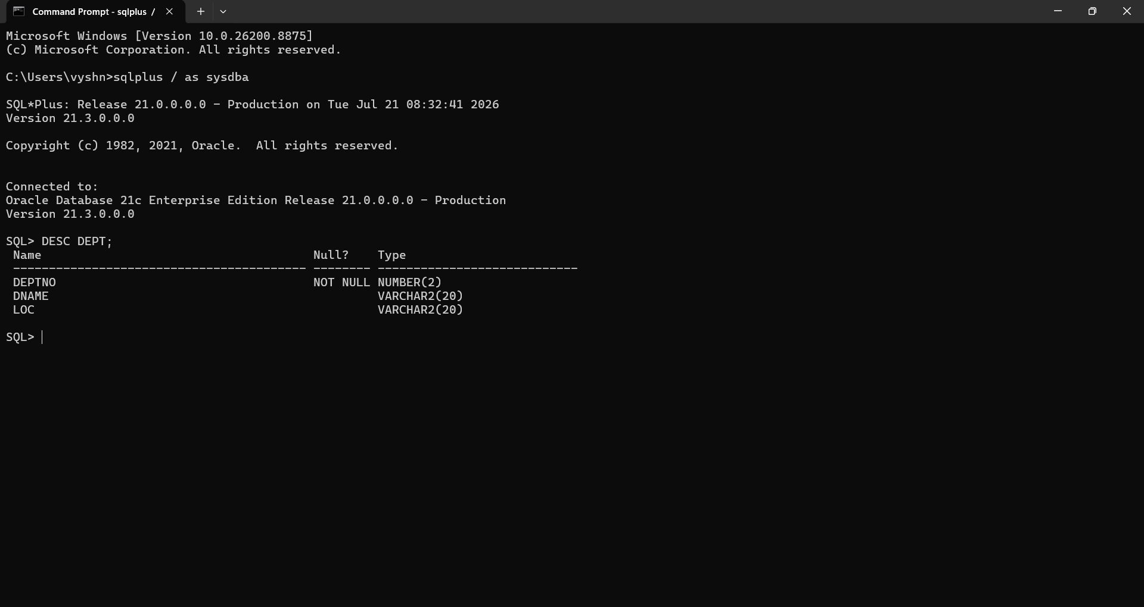
Contents:
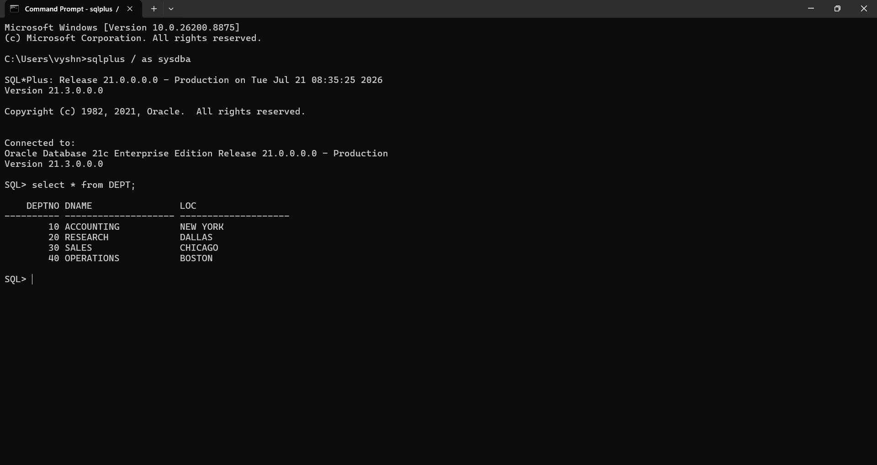

2.Determine the Structure of EMP Table and its Contents.
Structure of EMP:
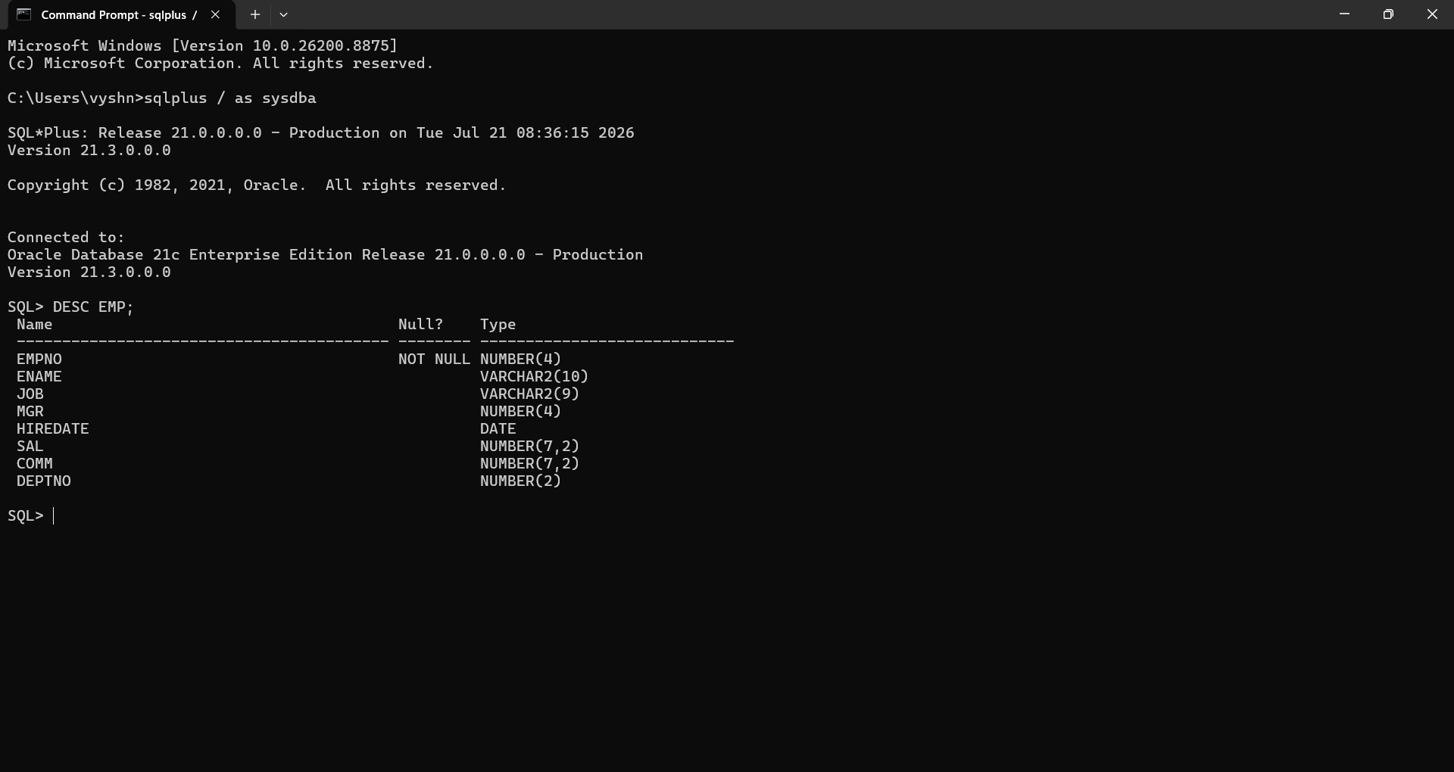
Contents:
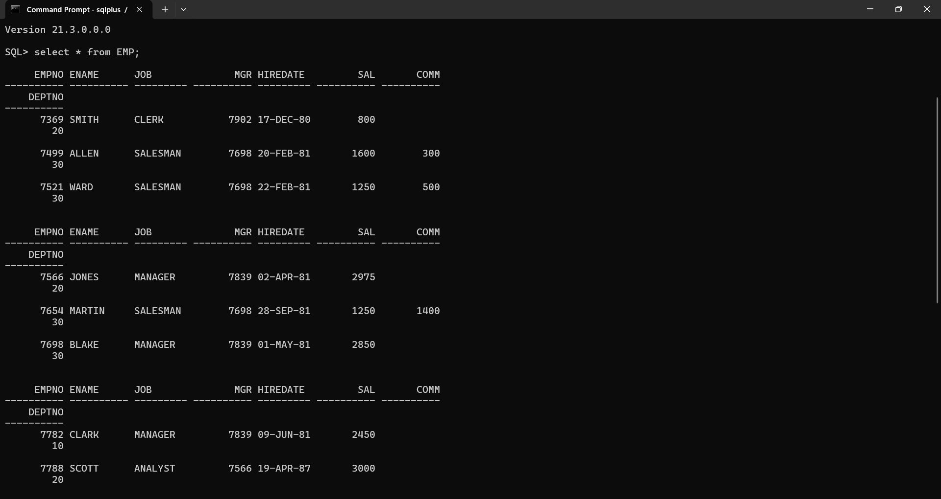

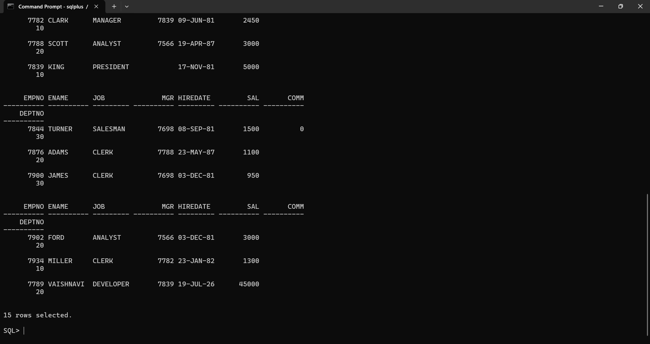

3.Display the Ename and Deptno from Emp table whose Empno is 7789.
